January 2019
THE KEYSTONE HIKER
Preserving Pennsylvania’s Footpaths since 1956

Contact us: 46 E Main St, Mechanicsburg, PA 17055 / 717-766-9690 / ktaadmin@kta-hike.org

Member’s Corner

Thank you, and Happy New Year
from Joe Neville, Executive Director
I have been your Director for exactly three and half years now and wanted to take this opportunity to communicate directly with you, our members, some of my thoughts. Ask anyone what they love most about work and in most cases, the first thing they mention is 'the people'. We spend a massive proportion of our life at work and we’re with the people we work with, and for, far more than our loved ones. You, the members, are what makes it all worthwhile.
I’ve found working for KTA brings together individuals from all walks of life, with interests outside of hiking which are as different as can be. This diversity makes all of you interesting, educational and certainly fun to be around.
You’ve supported us when we made mistakes, you’ve encouraged us to meet your goals. You provide a virtual, reassuring hand on the shoulder which is so very vital to us in the KTA office.
While we’re probably all fairly autonomous, there are always times when it’s good not to be on your own. Whether it’s putting several heads together to create the world’s next amazing idea, trying to figure out that word which is on the tip of your tongue or working late on Friday to carry out a program, it’s nice to have other people, like you, around. We truly enjoy our interactions with you and want to thank you for your continued support as we begin 2019 working together for Pennsylvania’s trails and hikers.

Laurel Highlands Hiking Trail
told by Wanda Shirk
The STS was my gateway drug. From the time that I hiked it, I was a trail addict. I needed more.
Among the dozens of trails and hundreds of miles I have hiked by now, the Laurel Highlands Hiking Trail is a favorite. I finally got around to hiking it just this past May, with my compadres Sue and Joanne, and we all agree that it’s one of the best trails in Pennsylvania.
The LHHT starts in southeast PA at Ohiopyle State Park, which is arguably the best of our 121 state parks. From there, the trail goes northeast for 70 miles. Unlike the STS, it’s a linear instead of a loop trail, requiring backpackers to get a shuttle from one end to another. However, the three of us were slackpacking, so we had no problem. Parking areas are large and conveniently located and spaced. The excellent trailheads, free maps, blazing, and trail maintenance are all pluses for the LHHT.
The unique thing about the Laurel Highlands Trail is that cement mile markers are placed every mile, standing about a foot high along the trail. It was always a pleasure to see the next mile marker, which we could usually anticipate coming across about every 25 minutes. The markers are engraved with each mile number, providing regular notice of progress and accomplishment.
Another feature unique to the LHHT is the regularity of shelter areas along the trail. The shelter areas are set back substantially from the trail, anywhere from a few hundred yards to a tenth of a mile or more. Each shelter area has five shelters, picnic tables, a water pump, and pit toilet facilities. Being close to the Pittsburgh population center, the LHHT receives substantially more foot traffic than the STS. Backpackers are allowed to camp only at shelter areas, and reservations are required.
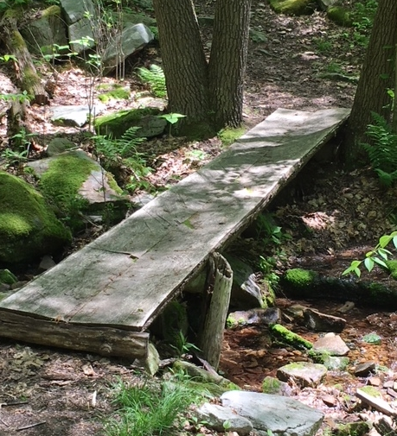
Pennsylvania’s southcentral and eastern trails are notoriously rocky: most Appalachian Trail hikers have heard the term “Rocksylvania.” The STS and the Quehanna Trail are two favorite northcentral trails because most of our treadway is fairly nice dirt trail and not rocky. The LHHT also has mostly rock-free path. The woods understory is mostly pleasant and open, rarely obscured by brush and briars clogging the path or a hiker’s view.
Like looking down on people? The most stupendous feature of the trail is the LHHT bridge over
the six lanes of the Pennsylvania Turnpike. The 10’ wide, 184’ long bridge for hikers and snowmobiles, completed in 2012, cost $1.3 million! However, another of our favorite trail features on the LHHT was the many simple log bridges. Wet crossings never had to be feared. Boards or flattened logs provided sturdy footing even across some dry ditches.
Nature grants special favors to some trails. To the LHHT, it has granted two highlights. One is a section with spectacular views of the “Yock” – Youghiogheny River. Another is a couple sections with humongous rocks and boulders that hikers marvel at as they wind through narrow passages. Unfortunately, the STS has no comparable features – though we do have the Hammersley Pool!
Between miles 6 and 8 of the LHHT, the trail has an elevation change from 1500’ to 2400’ – 900 feet that hikers definitely want to do in a SOBO (southbound) direction. Other than that stretch, most of the LHHT is fairly level, atop the “highlands” for which it is named. This makes easy hiking.
Maintainers on the LHHT built one of the most fun things we ever saw on a trail. A large-diameter blowdown was cut into chunks that were made into chairs – with backs! One chunk about two feet high was set up as a table. It was cross-hatched to make a tic-tac-toe board on top. Then a skinny blowdown with a diameter of about three inches was sliced to make discs to play as “O”s on the board, and some of the discs were squared off to make the “X” discs. This was the most creative work with blowdowns that we have ever seen. What a way to bring smiles at a snack or lunch stop!
We hiked the trail over six fairly leisurely days. Except for the southernmost section with the steep hill, which we hiked together SOBO, we did “key exchange” hikes. I would park at the north end and hike south. Joanne and Sue parked at the south end and hiked north. We would meet in the middle each day, exchange vehicle keys, and later meet back at the Cobblestone Inn where we stayed. Key exchange hikes save a lot of time in car-posting-shuttles each morning and afternoon.
If you’re a trail addict like me, I highly recommend the Laurel Highlands Hiking Trail to you!

Hik(e)u
by Ed Lawrence
Trail Care Schedule
dense as hophornbeam
yet, it floats

Volunteer/Maintainer’s Junction

2019 Trail Care Schedule

April 4-7: Trail Care BTD
North Country Trail
Slippery Rock Gorge
McConnells Mill State Park

April 25-28: Trail Care BTD
Mid State Trail, State College Region
Rothrock State Forest

May 2-5: Trail Care BTD
Chuck Keiper Trail
Sproul State Forest

May 14-19: Trail Crew Week
Baker Trail

May 16-19: Trail Care BTD
Hickory Run State Park

May 30- June 2: Trail Care BTD
Mid State Trail, Woolrich Region
Tiadaghton State Forest

June 6-9: Trail Care BTD
Black Forest Trail
Tiadaghton State Forest

June 20-23: Trail Care BTD
Mid State Trail, Tioga Region
Tioga State Forest

June 27-30: Trail Care BTD
Golden Eagle Trail
Tiadaghton State Forest

July 11-14: Trail Care BTD
Allegheny Front Trail
Moshannon State Forest

July 25-28: Trail Care BTD
Tracy Ridge Trail System
Allegheny National Forest

August 8-11: Trail Care BTD
Mid State Trail, Everett Region
Buchanan State Forest

August 22-25: Trail Care BTD
Thunder Swamp Trail System
Delaware State Forest

September 12-15: Trail Care BTD
Tuscarora Trail
Cowan’s Gap State Park

September 26-29: Trail Care BTD
Pinchot Trail
Pinchot State Forest

October 24-27: Trail Care BTD
Donut Hole Trail
Sproul State Forest

November 7-10: Trail Care BTD
Bucktail Path
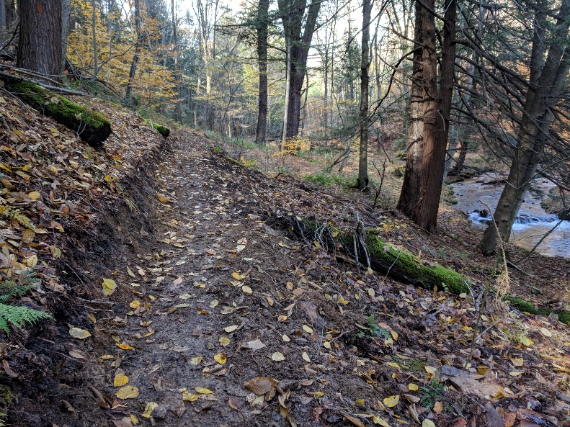
Elk State Forest

For more info on trail care or to sign up, click here!

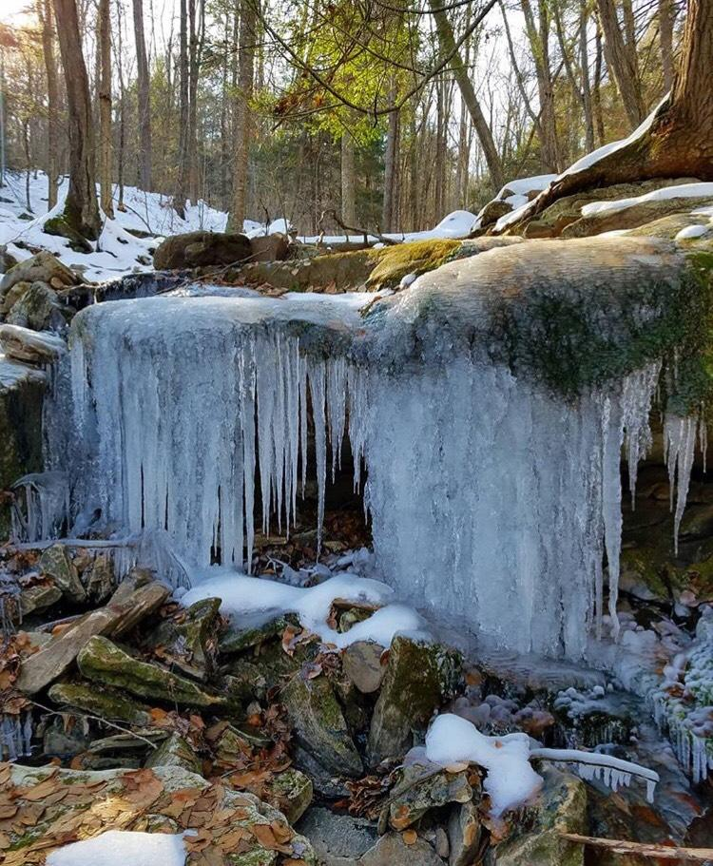
Jeff's Jaunts
Jeff Mitchell gives us a look at the winter wonderland that is World's End State Park.
﻿"Worlds End State Park is a hiking wonderland with a vast network of high quality trails that explore vistas, waterfalls, gorges, and large rocks. This system of trails is steadily expanding with the addition of a new trail-the yellow blazed East Branch Trail which explores the slope above the East Branch of Double Run." - Jeff Mitchell, East Branch and Canyon Vista Loop-World's End State Park, 2018

Community Calendar

Spring Hiking Weekend 2019- April 12-14; Camp Ladore Waymart, PA
Laurel Highlands Trail Slackpack- May 3-7
Trek the Tiadaghton- June 14th-16th
Adventure in the Allegheny National Forest- August 9th-11th
Trail Challenge- September 7th
KTA Treks & Trails Trip to Wales-Sept. 15th-27th
Quehanna Elk Quest trip 1- October 4th-6th

KTA will promote your club/organization's major events through The Keystone Hiker, Facebook, and our website. It's a perk of membership!
Just submit a list with date, time, location, and link to web page for only those events that the public should see, to info@kta-hike.org.

Newsletter Submissions

This newsletter is published monthly by Keystone Trails Association. Submissions are accepted on a rolling basis. Opinions expressed are those of the listed authors. The Editor encourages submissions reflecting all viewpoints, but reserves the right to edit material. You are encouraged to submit material (even just a trail closing or care alert!) to the Program Administrator, Cameron Elo, at ktaadmin@kta-hike.org. The deadline for newsletter submissions is the 15th of the prior month. Submissions received after that time will be considered for the next month.

Please reference our Editorial-Style Guide while you compose your piece.

