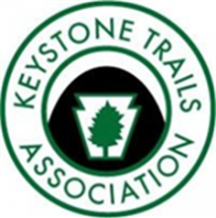
February 2019
THE KEYSTONE HIKER
Preserving Pennsylvania’s Footpaths since 1956

Contact us: 46 E Main St, Mechanicsburg, PA 17055 / 717-766-9690 / ktaadmin@kta-hike.org

Member’s Corner

In Gratitude for PA Hiking
by Kay Owen and Louise Baker, KTA Members

Our hiking world has expanded in 2018 thanks to KTA! One of us had been a member but had not gone on any of the hikes. The other had never even known such an organization existed. We and the men in our lives did two hikes in 2018: the Quehanna Elk Quest in September and Gettysburg in November. Our world has been enriched by the experiences!
As relatively new hikers and new members to KTA, there are a number of services and amenities provided by KTA that we particularly enjoyed.
- We did hikes in Pennsylvania in places that we had never seen before. As lifetime residents of PA, we saw parts of the state we had never visited before in a hiking way. What beauty our state has!
- The hike leaders were experienced and knowledgeable about the area of the hikes. As participants, we learned about the history, geography, wildlife, climate, and culture of the respective areas.
- The staff of KTA took care of all the arrangements for lodging and meals. All we had to do was show up and hike! There could not have been an easier way to do a hike.
- We had the wonderful opportunity to meet fellow hikers from other regions of the state. We met some fascinating people, all with their own stories. Our paths crossed with people that most likely we would not have met in the normal course of our lives.
- The staff of KTA set the tone for a relaxed camaraderie among the participants. The flexibility of joining all the activities or any part of them made the trips extremely personalized and enjoyable.
- Safety and comfort of the participants was clearly a priority without making a big deal of it. We were well taken care of.
- The price is right for the trips. We feel we got a lot for our money.

The four of us enjoyed the 2018 hikes so much that we have signed up for three hikes in 2019!
Thanks to Joe and Cameron for making our experiences so incredible in 2018. Thanks also to the Board of KTA for carrying out their mission!

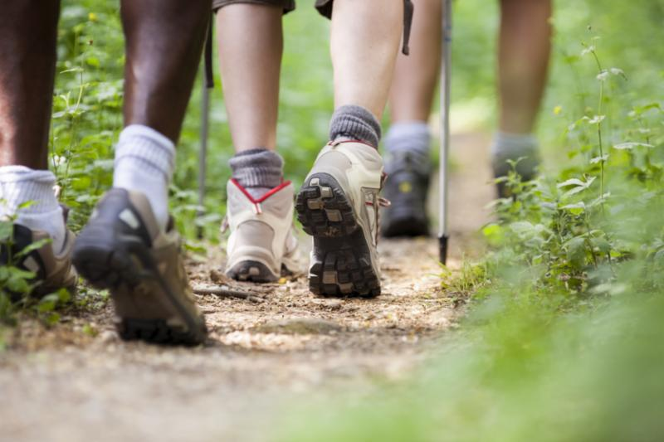
My Turn: Keep the Ban on Sunday Hunting
by Paul Shaw, from an article on dailyitem.com
"Sunday hunting, with a few exceptions for varmints, has been banned in Pennsylvania since 1873. Originally a 'blue law' encouraging people to attend religious services, the Sunday hunting ban has helped nurture non-hunting outdoor recreation without hurting Pennsylvania’s hunting tradition. In the entire nation, only Texas has more licensed hunters than Pennsylvania.
Last summer, HB 1374 was introduced in the state house, a bill that would grant the Game Commission authority to lift the ban. In past years, similar bills have withered on the vine for lack of support, but this bill is different because of the active support of the NRA. Besides organizing a petition drive, the NRA is reputedly making this a scorecard issue to grade legislators. The bill is expected to be taken up in the house in the near future. Lifting the ban is not only bad for the multitude of Pennsylvanians who flock to the woods on Sundays for non-hunting pursuits, but in the end, it is also bad for hunting."
To read the entire article, click here .

______________________________________________________________________________________________________

Did you know that KTA will accept non-monetary donations? We'll gladly take your old boat, car, etc! We're specifically looking for a 12 or 15 passenger van to use on our slack packs and to shuttle hikers on a variety of our programs.
If you have something you'd like to donate, please contact Joe Neville at ktahike@kta-hike.org

Your Hiking Advocate

KTA BOARD REAFFIRMS OPPOSITION
Mechanicsburg, PA, January 8, 2019 – At the January meeting of Keystone Trails Association’s (KTA) Board of Directors, the Board reaffirmed the organization’s opposition to any expansion of Sunday Hunting in Pennsylvania. Board President Ernie Werstler noted that the Power of Outdoor Recreation Spending in Pennsylvania: How hunting, fishing, and outdoor activities help support a healthy state economy of November, 2018 By Southwick Associates and the Theodore Roosevelt Conservation Partnership showed that trail users outnumbered hunters 3 to 1 and their economic impact was higher than hunters by 2.5 to 1. Trail users spent $2574 per participant according to the analysis. “Clearly the non-hunting public needs to have significant input into this issue since their economic impact is so substantial”, he said, “Any expansion of Sunday hunting could have a very detrimental economic impact on our economy if trail users discontinue their activities to avoid hunters.”
“While the reasons for opposition to this issue are as many and varied as our membership, including fearing for their safety, the overwhelming majority do not want to see any expansion of Sunday hunting in Pennsylvania. It is vitally important that our elected officials listen to the large majority of people in our state on such an important issue.” Werstler added.
In addition, the Board noted that the 2016 National Survey of Fishing, Hunting, and Wildlife-AssociatedRecreation showed that significantly more people participated in wildlife watching than hunting and again had a larger economic impact.

Please contact your legislators today and ask them NOT to support or co-sponsor any bill introduced to allow hunting on Sunday!
Contact legislator info here: http://bit.ly/findPAleg .
Reasons to oppose Sunday hunting here: http://bit.ly/KeepSundaysSafe

Volunteer/Maintainer’s Junction

Trail Care 2019: The Work is the Reward
by Ed Lawrence
The 2019 KTA Trail Care schedule is packed with opportunities to “give back” to one of your favorite trails, or one you’ve always wanted to hike, by participating in a group effort dedicated to keeping hiking trails open and accessible for this year’s calendar of hiking adventures. Volunteers will be needed to help improve the treadway on sections of the Golden Eagle Trail (which Tom Thwaites described as the best day hike in Pennsylvania) in June and the Tracy Ridge Trail System in July. The Trail Care Program will be returning to help clear the corridor of the Allegheny Front Trail, based out of Black Moshannon State Park and KTA volunteers will again be partnering with Friends of Pinchot State Park for a Code Orange 1 day event on Saturday, October 5th. The season will kick off the first weekend in April working on the part of the North Country National Scenic Trail that passes through Slippery Rock Gorge. For the first time, a Trail Care weekend event will focus entirely on a State Park, Carbon County’s 16,000 acre Hickory Run, with its 44 miles of hiking trails, or volunteers can head to western Pennsylvania that same week for this year’s only 6 day crew and experience the extended satisfaction of improving the Baker Trail, with meals included. All of the weekend Trail Cares this year have the BTD designation (Bonus Trail Day) meaning that, for those volunteers who are available, Friday will be a planned work day as well as Saturday and Sunday till noon. Camping will be available at all Trail Cares Thursday, Friday and Saturday nights at the listed venue. Always contact the leader to find out detailed and updated information. The Trail Care Program is an all volunteer opportunity for hikers to give the footpaths they tread and enjoy a meaningful “bear hug”, and it is a great, and humble, way to enhance trail karma.
2019 Trail Care Schedule

April 4-7: Trail Care BTD  North Country Trail  Slippery Rock Gorge  McConnells Mill State Park  ﻿Leader: Dave Adams, but@northcountrytrail.org  Camp: Breakneck Campground  Moraine State Park  April 25-28: Trail Care BTD  Mid State Trail, State College Region  Rothrock State Forest  Leader: Kevin Busko, statecollege@hike-mst.org, 814-643-4238  Camp: Greenwood Furnace State Park  May 2-5: Trail Care BTD  Chuck Keiper Trail  Sproul State Forest  Leader: Tony Robbins, tony.robbins.kta@excellservices.com,  570-437-0065  Camp: Middle Branch Camp 3 miles down Penn Rose Road off Rte. 144 between Snowshoe  and Renovo  May 14-19: Trail Crew Week  Baker Trail  Leader: Dewaine Beard, dewaineb@gmail.com, 412-719-9904  Creek Bend Campground  May 16-19: Trail Care BTD  Hickory Run State Park  Leader: Ed Lawrence, cemclaw216@gmail.com, 570-925-5285  Camp: Org. Group  Tent site J  May 30- June 2: Trail Care BTD  Mid State Trail, Woolrich Region  Tiadaghton State Forest  Leader: Joe Healey, jnlhealey@aol.com, 570-655-4979  Camp: Ravensburg State Park  June 6-9: Trail Care BTD  Black Forest Trail  Tiadaghton State Forest  Leaders: Jenn Ulmer / Donna Thompson, Hawk2373@yahoo.com,  570-854-8316  Camp: Ruth Will Cabin at Pump Station Fire Tower  June 20-23: Trail Care BTD  Mid State Trail, Tioga Region  Tioga State Forest  Leader: Peter Fleszar, tioga@hike-mst.org, 717-583-2093  Camp: Twin Streams Camp Ground, Morris  June 27-30 : Trail Care BTD  Golden Eagle Trail  Tiadaghton State Forest  Leader: Wanda Shirk, wshirk49@outlook.com, 814-848-7944  Camp: Black Walnut Bottom on Route 414, south of Slate Run | July 11-14: Trail Care BTD  Allegheny Front Trail  Moshannon State Forest  Leader: Ben Auer, auer.ben@gmail.com, 608-772-1715  Camp: Black Moshannon State Park  Group Tenting Area  July 25-28: Trail Care BTD  Tracy Ridge Trail System  Allegheny National Forest  Leader: Tina Toole, anf@northcountrytrail.org, 814-723-4714  Camp: Tracy Ridge Campground  August 8-11: Trail Care BTD  Mid State Trail, Everett Region  Buchanan State Forest  Leader: Ed Lawrence, cemclaw216@gmail.com, 570-925-5285  Camp: Tenley Park, Everett  August 22-25: Trail Care BTD  Thunder Swamp Trail System  Delaware State Forest  Leader: Ed Lawrence, cemclaw216@gmail.com, 570-925-5285  Camp: Resica Falls, Boy Scout Camp  September 12-15: Trail Care BTD  Tuscarora Trail  Cowans Gap State Park  Leader: Ben Auer, auer.ben@gmail.com, 608-772-1715  Camp: PATC Cabin at Little Cove  September 26-29: Trail Care BTD  Pinchot Trail  Pinchot State Forest  Leader: Jeff Mitchell, jmitchmitch@hotmail.com, 570-441-2952  Camp: Manny Gordon  Picnic Area  October 5: Code Orange 1 day  Gifford Pinchot State Park  Leader: Steve Stroman, stevestroman@hotmail.com, 717-350-0437  Meet at 8:30 at the campground office off East Camping Area Road. Camping available Fri. & Sat. Cookout for volunteers  ﻿October 24-27: Trail Care BTD  Donut Hole Trail  Sproul State Forest  Leader: Tony Robbins, tony.robbins.kta@excellservices.com, 570-437-0065  Camp: Hyner Run State Park  November 7-10: Trail Care BTD  Bucktail Path  Elk State Forest  Leader: Rick Hiemenz, mustardgarlic@hotmail.com, 814-706-8218  Camp: Brooks Run  Fire Tower Cabin  For more info on trail care or to sign up ,click here !

Fundraising
KTA is seeking volunteers interested in assisting us with some fund raising/development ideas for the upcoming year. For more information or to share some ideas please contact Cameron Elo at ktaadmin@kta-hike.org

Hiker’s Corner

Jeff's Jaunts
Jeff's January adventures included exploring Colley Falls.
"The falls are about 20-25 feet tall and tumble over tiers of bedrock. I was surprised by the beauty of the falls. A small side stream joins below the falls. Colley Falls is by far the largest and most scenic of the falls, so most people will choose to stop here. If you’d like to see the other falls and cascades, continue up the grade." - Jeff Mitchell, Hike to Colley Falls-SGL 66
To read more, click on the photo to the right!

Sign Up for 2019 Events NOW

Click the images below to get more info, and to sign up today!

Spring Hiking Weekend  Laurel Highlands Slackpack | KTA Trail Challenge  Quehanna Elk Quest | Trek the Tiadaghton  Adventure in the Allegheny

Newsletter Submissions
This newsletter is published monthly by Keystone Trails Association. Submissions are accepted on a rolling basis. Opinions expressed are those of the listed authors. The Editor encourages submissions reflecting all viewpoints, but reserves the right to edit material. You are encouraged to submit material (even just a trail closing or care alert!) to the Program Administrator, Cameron Elo, at ktaadmin@kta-hike.org. The deadline for newsletter submissions is the 15th of the prior month. Submissions received after that time will be considered for the next month.
Please reference our Editorial-Style Guide while you compose your piece.

