August 2019
THE KEYSTONE HIKER
Preserving Pennsylvania’s Footpaths since 1956

Contact us: 46 E Main St, Mechanicsburg, PA 17055
717-766-9690 / ktaadmin@kta-hike.org

Member Square
_______________________________________________________________

KTA Members Recognized by DCNR for Conservation Volunteer Work

The Bureau of Forestry of the Pennsylvania Department of Conservation and Natural Resources (DCNR) recently took the time to recognize the conservation volunteer work of KTA members Jane Huston and Ernie Werstler on the Mid State Trail.

In a recent letter, Matthew R. Beaver, District Forester said the following of their work:

“I want to take this opportunity to formally recognize the outstanding efforts of your volunteer work on the Mid State Trail on the Bald Eagle State Forest. Your tireless efforts have been vital to the high-quality maintenance of the trail. You are a shining example of how volunteer collaboration can provide a great service to its members, the state forest system, and the citizens of the Commonwealth.

The volunteers are a part of the Department of Conservation and Natural Resources’ (DCNR) Conservation Volunteer Program, launched June 24, 1997, by Gov. Tom Ridge. The Conservation Volunteer Program encourages active participants to help the Department carry out its mission of stewardship of the state park and state forest lands.

The Bureau of Forestry applauds the contributions from both you and the Mid State Trail Association promoting hiking trail improvements in our state parks and forest. On behalf of the Bald Eagle State Forest, I wish to extend my sincere appreciation for your past accomplishments, and I look forward to future partnership opportunities for the benefit of state forests.”

Volunteer/Maintainer’s Junction

2019 Trail Care Schedule

*CODE ORANGE EVENT ADDED TO SCHEDULE*

The Friends of Keystone State Park groups will be hosting a Code Orange work day on Saturday, August 17, 2019. Participants can join with the Friends to improve the hiking trails in the park. KTA Trail Care volunteers last worked in Keystone State Park in 2011.

August 22-25: Trail Care BTD

Thunder Swamp Trail System
Delaware State Forest
Leader: Ed Lawrence, cemclaw216@gmail.com, 570-925-5285
Camp: Resica Falls, Boy Scout Camp

September 12-15: Trail Care BTD

Tuscarora Trail
Cowans Gap State Park
Leader: Ben Auer, auer.ben@gmail.com,
608-772-1715
Camp: PATC Cabin at Little Cove

August 22-25: Trail Care BTD
Thunder Swamp Trail System
Delaware State Forest
Leader: Ed Lawrence, cemclaw216@gmail.com, 570-925-5285
Camp: Resica Falls, Boy Scout Camp

September 12-15: Trail Care BTD
Tuscarora Trail
Cowans Gap State Park
Leader: Ben Auer, auer.ben@gmail.com,
608-772-1715
Camp: PATC Cabin at Little Cove

September 26-29: Trail Care BTD
Pinchot Trail
Pinchot State Forest
Leader: Jeff Mitchell, jmitchmitch@hotmail.com, 570-441-2952
Camp: Manny Gordon Picnic Area

October 5: Code Orange 1 day
Gifford Pinchot State Park
Leader: Steve Stroman, stevestroman@hotmail.com,
717-350-0437
Meet at 8:30 at the campground office off East Camping Area Road.
Camping available Fri. & Sat. Cookout for volunteers

﻿October 24-27: Trail Care BTD
﻿
Donut Hole Trail
Sproul State Forest
Leader: Tony Robbins, tony.robbins.kta@excellservices.com,
570-437-0065
Camp: Hyner Run State Park

November 7-10: Trail Care BTD

Bucktail Path
﻿Elk State Forest
Leader: Rick Hiemenz, mustardgarlic@hotmail.com,
814-706-8218
Camp: Brooks Run

Email us at info@kta-hike.org or visit us at www.kta-hike.org

___________

Trail Building near Palmerton
Superfund? Sounds a bit like super fun! Join the Appalachian Trail Conservancy's Mid Atlantic Crew for a week of trail building at a one-of-a-kind site on the A.T. near Palmerton, PA.
Years of dumping heavy metals as a byproduct of zinc smelting left the landscape surrounding the mining town of Palmerton in devastation. The Environmental Protection Agency (EPA) declared the area a Superfund site, making it a national priority to remove the hazardous waste due to its potential risks to human health and the environment. After years of remediation, this rocky ridge provides poor Trail conditions for its current route. due to its potential risks to human health and the environment.

An alternative twelve-mile reroute of the Appalachian Trail has been identified for this unique location. The Mid-Atlantic crew is tasked with building a trail to help protect this recovering landscape. Projects may include vegetative clearing, tread definition, side hill tread construction, stone step installation or crib wall construction. The crew will be tenting at a nearby campground.

You can find more information and registration details here.

________

2019 KTA Trail Challenge

It takes over 120 volunteers to pull off this large event. Please consider signing up for multiple shifts if you are able. We will try to accommodate your shift preferences as best we can. You will receive an email confirmation after signing up. If you do not receive an email, please contact us. Volunteers receive an official KTA Trail Challenge Volunteer t-shirt, access to the delicious Finish Line Picnic, and the awesome feeling that comes with doing good. Thank you so much for supporting Keystone Trails Association!

You can find more information on volunteering here.

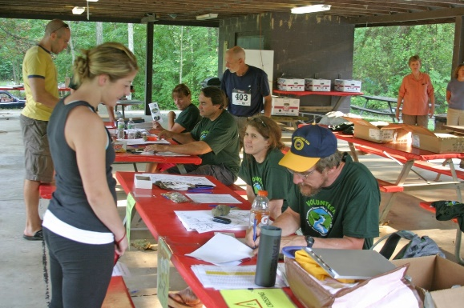

Hiker’s Corner

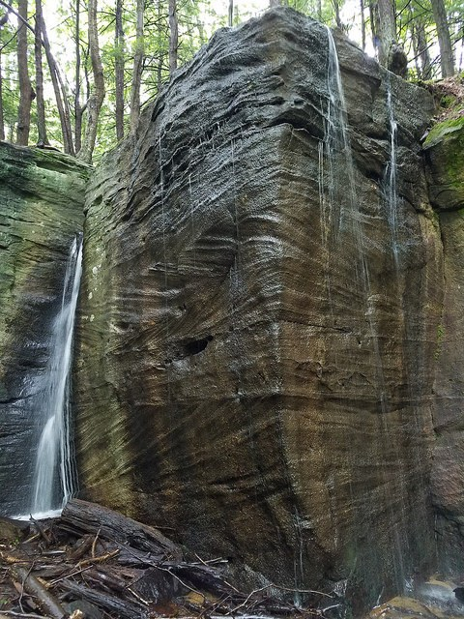
JEFF'S JAUNTS

Hiking to Hector Falls - Allegheny National Forest

Hector Falls is one of the most unique waterfalls you will ever see. Here, a small stream tumbles over both sides of a rectangular rock outcrop, creating a visual spectacle when it is flowing. The falls are described in Hiking the Allegheny National Forest.

From FR 258, go around the gate and hike the forest road. The road is surrounded by mature forests, although an area has been logged off to the right. The forest road descends into a wooded valley. Avoid an obvious grade or old forest road to the right and descend to the left. Reach an opening with a small gas well. Here, the forest road ends.

Follow the obvious trail into a beautiful hemlock forest. You will soon reach the top of the falls at a cliff and giant boulders. The creek is small and often dry in summer. When the creek is flowing well, the waterfall forms a unique veil off the ninety degree angled rock outcrop. The falls are about 22 feet tall and the base is located in a grotto of cliffs and large boulders. The setting is incredibly scenic.

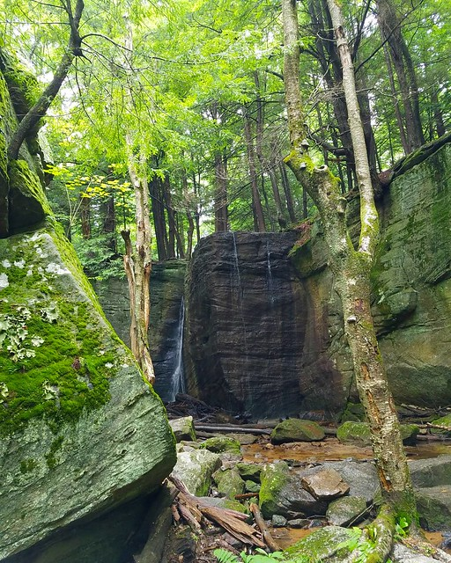
Below the falls, the small stream almost takes a subterranean route in the sand and under the boulders. Take some time to explore to large outcrops below the falls. Return the way you came.

The hike is .9 mile one way, and there are no signs or blazes on the trail. Hopefully, the Allegheny National Forest will put in an official trail to this popular spot, and protect it for future generations.

Directions: From Ludlow at Route 6, take South Hillside Avenue (or Road). Turn left onto Water Street. Turn right onto Scenic Drive. Cross the railroad tracks and the road becomes gravel. You are now on FR 133. Follow for one mile. Turn right onto FR 258 and follow for 2.1 miles to a pull off and gate on the left. This is the start of the hike. The parking area is at approximately 41.695827, -78.980782.

Sign Up for 2019 Events NOW

Adventure in the Allegheny National Forest – August 9th – 11th

Trail Challenge – September 7th

Quehanna Elk Quest Trip – October 4th – 6th

Fall Hiking Weekend - October 11th – 13th

Community Calendar

PA Greenways & Trails Summit – September 22-24
For more information on the event: www.greenwaysand trails.org/2019summit

Want your event featured on the Community Calendar?
Submit to info@kta-hike.org: A list with date, time, location and link to the webpage.

^{Newsletter Submissions}

This newsletter is published monthly by Keystone Trails Association. Submissions are accepted on a rolling basis. Opinions expressed are those of the listed authors. The Editor encourages submissions reflecting all viewpoints, but reserves the right to edit material. You are encouraged to submit material (even just a trail closing or care alert!) to the Program Administrator at ktaadmin@kta-hike.org. The deadline for newsletter submissions is the 15th of the prior month. Submissions received after that time will be considered for the next month.

Keystone Trails Association I 717-766-9690 I info@kta-hike.org
www.kta-hike.org

